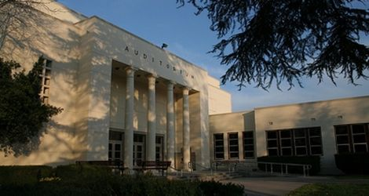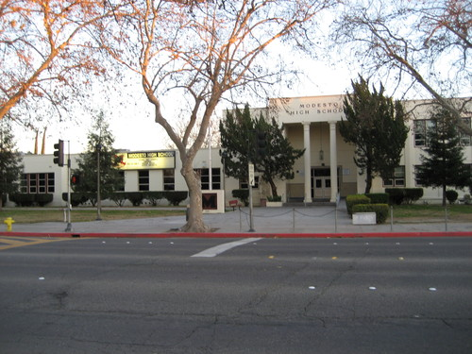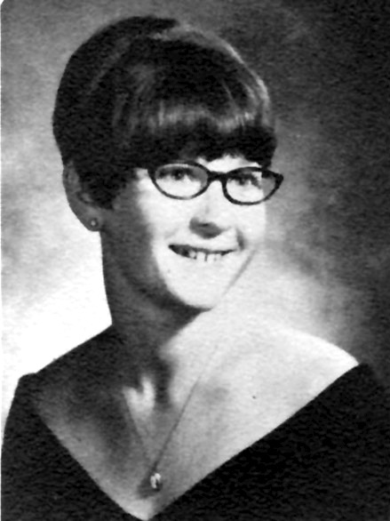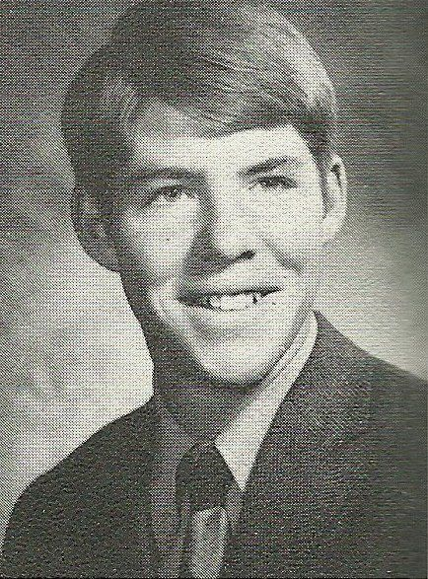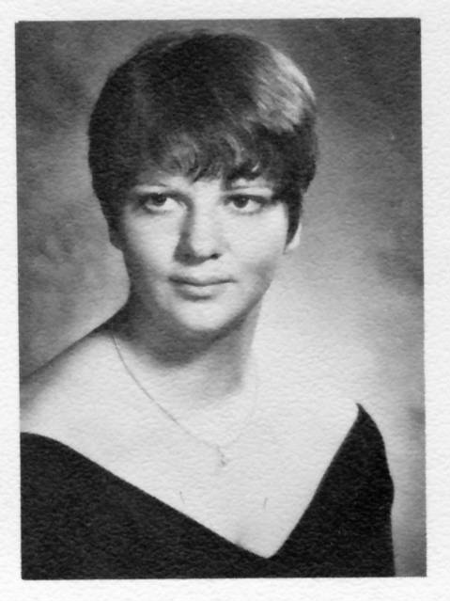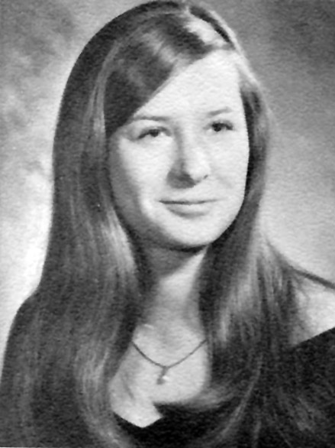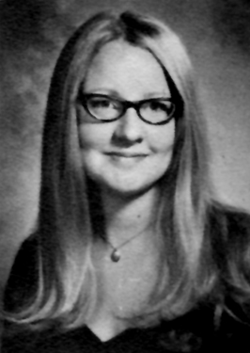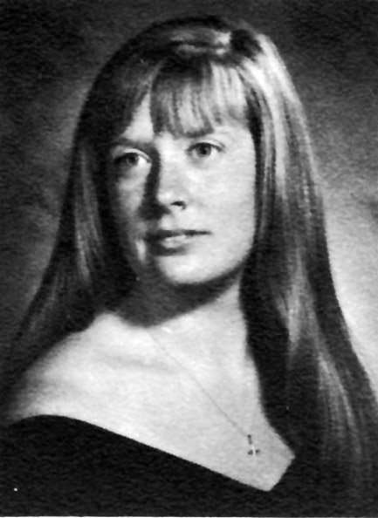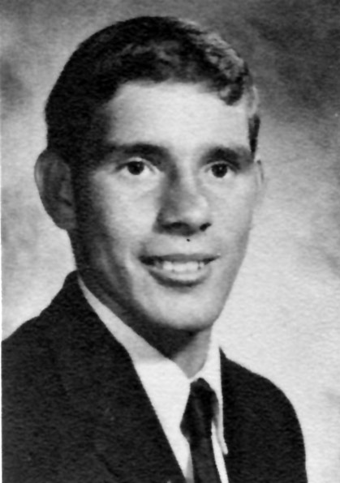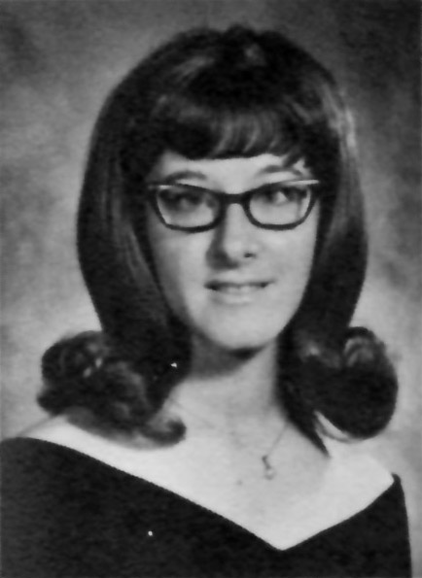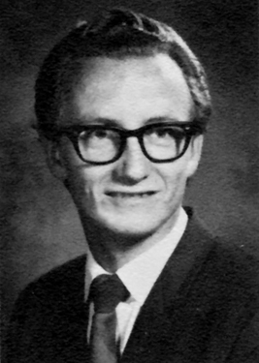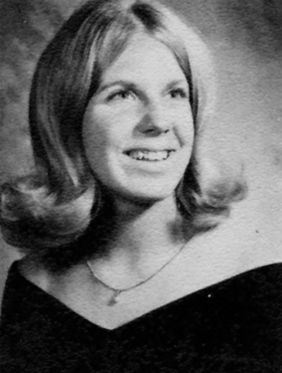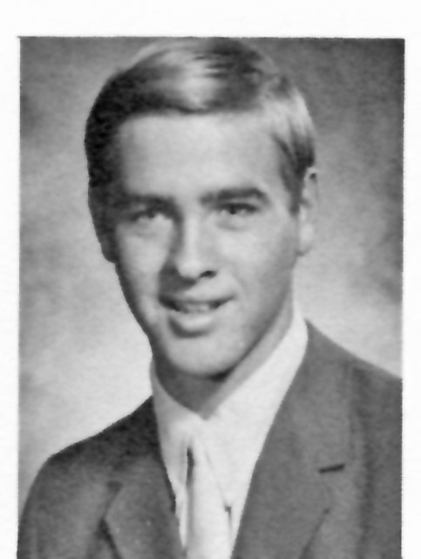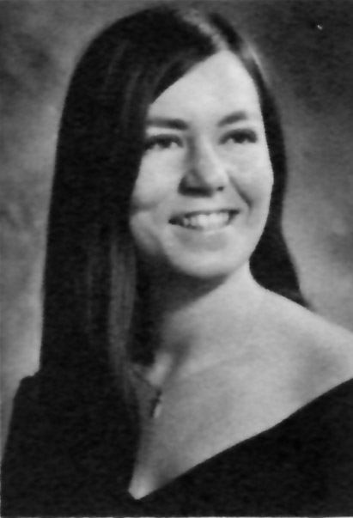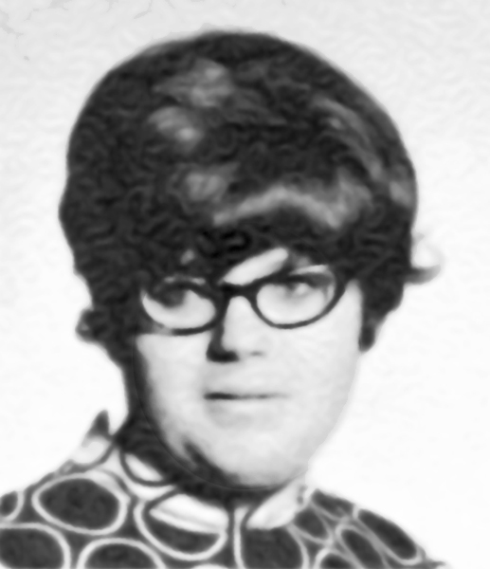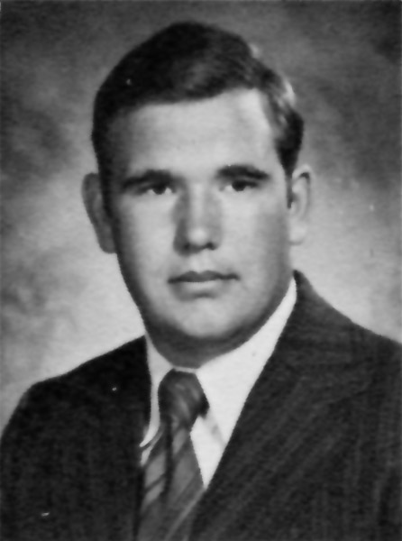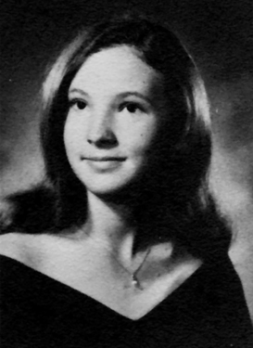

For four years we were Panthers. 40 years later we are still Panthers with 128 years of Panther Pride coursing through our veins. There may be other high schools in Modesto, but there is only one Modesto High School, and we are all inextricably part of its rich history and its extended family. As we come together for our 40th class reunion, we have the opportunity to reconnect with our MHS family, renew old acquaintances, establish new friendships, share old memories and create new ones. Consider this our *Garden Party* …

*I went to a garden party, to reminisce with my old friends, a chance to share old memories and play our songs again …* – Ricky Nelson

**The Broadcast: *Special Edition***

MHS Class of ’71 40th Reunion

# Classmate Bio’s

All hail to thee, Modesto High;

Let not thy soaring echoes die.

In black and crimson majesty;

Thy colors stand for victory.

Thy loyal sons and daughters raise

To thee in ever reverent praise.

A song sent ringing into the sky;

All hail to thee,

MODESTO HIGH!

#### Modesto High School Hymn

## Patty Amador

Married my high school sweetheart, Mark Hawn (class of 70) 37 years ago. We have 2 sons, Jared and Greg, 1 daughter in love, Lyndi, and a 1-year-old grandson, Koen.

I have been a stay-at-home mom most of my married life. Mark is assistant director of the pharmacy at Doctor's Medical Center.

We are very active in our church, Crosspoint Community Church (formerly 1st Baptist) here in Modesto.  I am working with the MOPS group there (Mothers Of Preschoolers)

We are loving our God, our lives, and our family. We are blessed.

We do not remember days; we remember moments.

- Cesare Pavese

Hi Class of 71, Well, I have been happily married 38 years this February to Sylvia, my best friend , my lover and the one that keeps me in line, We have one grown son Jared. As a family we enjoy anything outdoors - camping, fishing, and trying to make the garden grow faster than the weeds. We both love the beaches as much as the mountains. But living so far out in the country we take a lot of stay-cations.

I worked for U.O.P. for 15 years, and ran a few small businesses. My wife has been a nurse for 33 years. Am sorry we have a wedding the same day as the reunion in Southern California and may not make it back in time. My hat is off to the wonderful people that put in all the work and hours so we can all stay in touch. ALWAYS A PANTHER!

## Charles Bower

## Debby Asher Hawn

I moved from Modesto in 1974. Married to Clyde Pollard for the last 19 years. We have one daughter, Darian (from a previous marriage), and she works for the Texas State Attorney General in Child Support Division. I have 4 granddaughters- Stephanie, 20, Samantha, 18, Tiphanie, soon to be 18, and Jordan, 9.

Went to MJC for a couple of years where I was involved in music and theatre, and learning to fire weapons in the CJ program. I attended and graduated from Cumberland College (now The University of the Cumberlands) in Williamsburg, Kentucky in 1986. I earned a Master's in Educational Diagnostics in 2005 from Sul Ross State University-Rio Grande College. This is my 26th year of teaching.

Clyde works for a private foundation and I hope to be joining the foundation soon in an administrative position.

One dog, Bozette, is a jet black Border Collie.

Hoping to use my new golf clubs when it gets cooler! Clyde and I enjoy practicing the art of watermelon sculpture with a 20 ga. Mossburg. For some reason there's only pieces left....

Things for me have stayed pretty much the same for the last twenty plus years.  I still own Ambeck Mortgage Associates and still live in Escalon on 75 acres.  My two daughters, like all of us, have grown older and are now 27 & soon to be 25.  No son-in-laws or grandbabies yet, but I'm confident both will come in time.

The biggest change for me has been the taking over of all of the farming operation from what had been done by a farm manager in the past.  I love the ranch and the tractor work. it's my refuge from the city and mortgage banking.  The acreage is in almonds and pasture.  In addition to a number of various farm animals, I purchased horses a year ago and have been taking riding lessons.  I guess the best way to sum it up is that I am doing well and very happy.  I love my family, I love where I live and I love what I do.

Looking forward to catching up with everyone on October 8th.

## Honora Adkins Pollard

Time endears

but cannot fade

the memories

that friends have made.

I work for an endodontist – have been here for 27 years and love my job as office manager. I’ve been married to Mark Brady for 30 years and have a lovely home in Visalia, CA. I have three sons: Matthew, 28, married; Michael, 26, married; and Mason, 20, single, in college and working I have two grandsons: Abraham, 2, and Ian, 3 months.

I love to ride my road bike, hike in the mountains, teach my Sunday school class, enjoy my Bible study group on Wednesday nights, and enjoy my time spent with family and friends. Thanks! See you there!

## Kathy Broughton Brady

Well, let's see...a brief synopsis of the past few years. I am married, happily to Bob Fish for 27 years now. We have been together for 31 years and have together raised 5 children. We are grandparents to 6 grandchildren with 2 more on the way.

I have pretty much been a mom and a student since I got out of the Army. I have had jobs here and there, but have spent most of my time raising the kids and going to school. I have AS degrees in Computer Aided Drafting and Design, Graphic Design and Photography, and I have a BA in Advertising/Graphic Design. I am now working on getting a home-based business started doing Photo Restoration, Photography, and Graphic Design.

Most of our travels have been either to Maine and New Hampshire to visit my husbands father before he passed; to Oregon...just to check out the lay of the land...we thought we might move up there at one point; to Colorado, to visit our son and his family...and to actually decided where we want to settle after Bob retires (probably in the Conifer/Baily area); and to Modesto (Ceres) to visit my mom.

I have to say that I am really glad that we have the Facebook page for the reunion this year. I didn't get anything for the 35th or I would have been there. It is so nice to be back in touch with so many people from high school.

Have three children, Eric, Seth and Elise. Eric is a fire fighter, and Seth has been in the Army for 11 years. He and Q are having their first child in September. It will be a girl and I a grandfather. I retired in 2006 from Jorgensen Company as the Division Manager of three of the five branch offices. I also served as the safety officer for the company for 25 years. I was with them for 30 years.

I retired with 21 years from the US Army in 1997 as a 1st Sgt. I have since received a commission in the US Army Reserve as a Captain. I currently serve as the Regional Sales Manager for Safety Manufacturers' Representatives (SMR). I joined SMR in 2006. I own a safety consulting and technical training company, "Safety Training Pays". I am a member of the American Legion, Modesto Engineers, Stanislaus County Safety Council. I play softball for a private draft league softball association, "Stanislaus Senior Softball Assoc" I play some golf, tennis, ride bikes often and enjoy motorcycle riding. I travel a lot so I struggle to find time to manage it all.

I was married for 33 years and am now single. I still find time to work and play. I went back at 52 and received my Masters Degree from Pacific University with a 3.75 GPA. Considering and investigating the possibility of returning to school to get my PHD, so that my kids have to call me Dr. Dad! I am in the motorcycle course at MJC and will get my license on Sunday Sept 4th. I then will keep a promise/pact that Lynn Grissom and I made in our senor year at MHS. We would ride motorcycles to Yosemite. Lynn never made that ride. On or about the third week of September, I and two friends that know of my need to make the ride will ride to Yosemite. If you would like to ride with us, come along. My friend and yours Lynn Grissom will be there making the ride with us. I am sure of that. It is a chapter of my life's book that I must complete. Then I will roller skate in Golden Gate Park in San Francisco.

## Eddie Brock

## Laura Brogdon Fish

My husband Steve and I were married in June of 1973.  We have 3 children, 2 sons age 34 & 33 and 1 daughter age 28.  My oldest son Clint has given me two beautiful granddaughters Isabella 7, and Sophia 4.  My middle son Wally was married 2 years ago and my youngest Marie just got married Sept. 3 of this year, so hopefully more grandchildren will be coming soon.

My husband and his partner bought the business Don's Mobile Glass together and after attending college all 3 of my children decided to come work for us.  I too work for my husband as the Human Resources Manager for the last 11 years.  It truly is a family business.

We have spent the last 6 years doing a lot of traveling.  We had a small plane (a Cessna 182) and have taken several trips across the states to different places.  I'm not a big fan of flying in small planes but my husband so loves it.  I secretly was very glad when he sold it a couple of years ago.  We have included in our travel abroad a trip to Paris, Spain, Italy, Greece, Istanbul, and Germany.  Next year we are planning a trip to the Ukraine.

Over the years we have managed to purchase a condo in Tahoe in Incline Village and a house in Monterey.  So we try to spend time at these places also when time allows.

Life has been pretty good to us.  I had a few health issues, but so far have overcame them.  Uterine cancer in 2008, broken leg in 2008, diagnosed with osteoperosis in 2009, gall bladder removal in 2010, but I have went a whole year (knock on wood) with no incidents and I'm feeling pretty strong.  I have a very adventurous husband and he is hard to keep up with, but he has lots of friends who can, so some things I don't have to experience.  He has been training for the last 6 months to do a Triathlon Sprint at Oakdale Lake in a couple of weeks.   We have learned to not take life for granted and to live each day as if it is our last.  We are truly blessed and have a beautiful life.

Hope I didn't bore anybody too bad, but Michael kept bugging us to get this in.  It has been such fun reading up on everyone on the website.  I'm really sad I can't make it to the reunion as we will be out of town that weekend and it is something I was not able to get out of.  Hope everyone has fun and we can keep on communicating with one another

.

(Continued on next page …)

Wow … I can’t believe that it has been forty years since we graduated from high school. Where does the time go?  I have been married to an amazing man, Bob, for over thirty-two years and together we have been blessed with our handsome son, Matthew, who turned twenty-nine this year.  My husband has been employed by Blue Diamond Growers since 1982, and I have been working the last twenty-eight years for the family business, Rolfes Engineering, Inc., as the office manager in Stockton, and since graduating from college, our son has worked as the computer programmer for the last seven years there too.

Even though we have not been blessed with grandchildren yet, we go to baseball, soccer, ballet, and other activities my sister’s grandchildren participate in.  We enjoy spending time with our families and traveling back East, especially to Branson, Mo, and the Monterey Peninsula, Northern California, and the Sierra Nevada, and we are going to Nashville & Memphis, Tennessee next year. We are looking forward to retirement and all that God has in store for us in the future.

I have been truly blessed, and God Bless Our Military (Past, Present and Future) Keep Them Safe because without them we would not be able to enjoy our freedom.

## Sandra Costa Rolfes

Separated after 30 years of marriage. Have three children, one son and two daughters and one grandson. I live in Mesa, Arizona that is located in the Phoenix metropolitan area.

## Norman Corn

## Susan Caudill Mort

It's hard to believe that it has been 40 years. Having raised 3 children and worked at the same company for 36 years, life has been a wild ride. My wife Shaula and I spend our time enjoying our church friends, cruising the computer, music, sewing, and mixing it up with our adult kids. Megan is married now and lives here in Modesto. Evan is single (and expected to marry soon) teaching at Kaplan College in LaJolla, and Grayson living in Fresno with his new wife. All are great citizens and now beginning their new walk in this life. I have had fun getting prepared for this reunion by downloading pictures of you all and listening to your stories along the way.  Have a great time at the reunion!

## Rick Conrad

#### Consectetuer:

I finished Modesto High in January 1971 because I was planning to get married to the love of my life Danny Emfinger.  We got married May 8, 1971.  I did however go back and receive my diploma with the class.  It did feel a little weird because I was already housekeeping and it seemed to me everybody else would be out partying that night.  My husband Danny and I went to my parents along with my sister Judy.  We had cake & ice cream with lots of family.

I gave birth to my daughter Cynthia Lee July 17, 1973.  She was my second love of my life and still is.  Now I watch her two daughters. Her 5-year-old looks just like her except she has brown eyes and Cindy has blue.

My husband Dan started working at Gallo Glass Plant in 1971 he also bought us a new home in 1971.  He worked hard and became a Machine Repairman.

Then April 24 1976 I gave birth to our son David Joseph Emfinger, my third love. Oh, by the way, I love all of them equally.

Danny had a bad head injury on August 18, 1980.  He has never been quiet the same as he was. I went to work and it was a difficult period in our life.  One of many.  However, when I promise to Love, Honor and Cherish till death do us part I mean it.  Plus the simple truth is I love my Danny more then any obstacles that have come up.

I finally worked as a construction secretary, which I really loved.  I was on the job for the building of Hanshaw Middle School.  Then I went to work for Jim Lockard. He was also my boss at the Hanshaw project.  Then we did all the background checking for Johansen High School.

After that job was complete is when I had the second most severe episode of Multiple Sclerosis.  It struck my eyes, my ability to walk and my speech.  I didn't have the memory that I had before, I couldn't type, or spell like I could before.  Just did a real number on me.  Danny was still having a hard time, but our two broken bodies made one pretty good one.  Plus we had our kids and family who helped us. Most important we had God in our corner.

The night before Danny's birthday, October 22nd, I was depressed because I couldn't see to drive and didn't have any money.  I wanted to get Danny a gift so badly.  The next morning I woke up and I could see again.  Danny said that was the best gift he had ever gotten.  I don't think I can go much further getting a little emotional.  God, Hope and Love … if we have these things we are rich.

(Continued on next page …)

## Sandra Davis-Emfinger

Married: Casey Campbell

Children:  Jessica Lewis & Tim Campbell

Grandchildren: Ashley, Kaitlynn, Brook

Hobbies: We have always been off-road enthusiasts from Pismo to Sierras.  We love to camp and ride our dune buggies.  A few years ago when my husband retired he decided to start Land Speed Racing and now we have a 1970 Chevy Pickup that we take to Bonneville and El Mirage that gets to a speed of 160mph.  This year our son Tim wanted to do circle track racing so they built a car and this is what they are now doing.  I have now told Casey that we need to do more traveling without race vehicles!  So some trips are in the works.

Church:  Member of Big Valley Grace

Work:   I was a nursing home administrator for 25 years.  Approximately 8 years ago I started Care Connections a Health Information Consultant company, and I work for attorneys to review medical cases and do all the workup for trials.  This year with a partner started Pacific Mediation Group, which provides mediation services to the public.

## Debra Cushenberry Campbell

After attending MJC I met my future wife "Rochelle" at Stan. State.  We were married in 1974.  We have three children, two girls and one boy.. Our son John is married and has our only grandchild, 3 yr, old Nicholas.  Our oldest child Kellie is in interior design in San Diego.  Our youngest Amanda is a gourmet chef.

Rochelle and I worked for Hershey Chocolate in Oakdale for 31 years before retiring in 2008.  We then moved to live in San Diego until Jan. 2011 when we moved back to live in Lodi.

When not working we spent our time seeing our country with our children.  After our last trip we have traveled over one million miles within the continental US.  Guess now its time maybe to see the rest of the world, maybe.

## Douglas Craig

My career began as graphic artist; ended up production manager & job estimator for printing company. I retired early to care for my parents. Volunteer work over the years includes: hospice, hospital, charity events like Relay for Life, art therapy, etc. I have been writing essays for [www.seniorwomen.com](http://www.seniorwomen.com/) for several years and have been published in one of the Cup of Comfort book series. I complete 1-3 commissioned paintings a year and have had work shown in a local gallery.

A couple of the more unusual highlights near the top of my list: being a crew member for a hot air balloon pilot and also one of the crew for the steam locomotive at Railtown 1897 State Historic Park in Jamestown. I have one son and two stepdaughters who have given my husband, Mike, and I a total of eight grandchildren.

## Roberta Costley McReynolds

Sandra Costa Rolfes (continued)

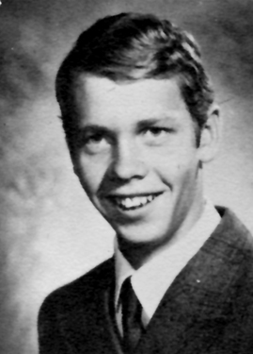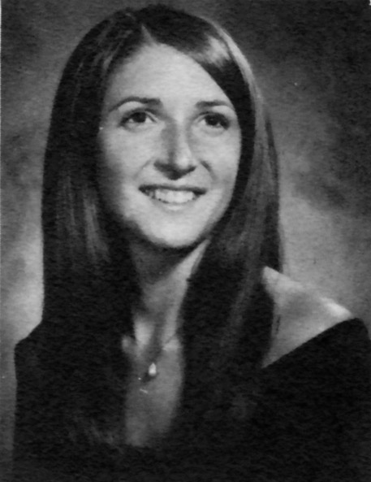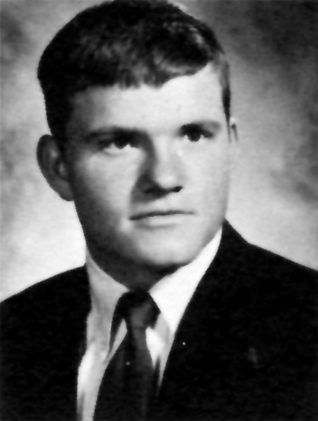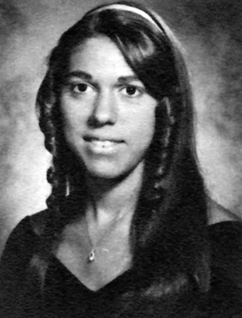 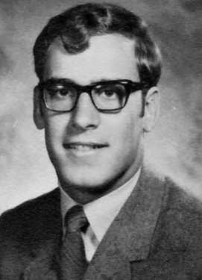

Don't count the years...

count the memories

## Jane Driver Richards

I think I filled out one of these forms for the last reunion, so here's the update since then.

Family:  Joel and I just celebrated 32 years of marriage. Our two oldest sons, Jordan and Ryan, graduated from college, both got married last fall, and work in Stockton. Daughter, Katie, is working on a Master's degree at CSU Fullerton. Son, Will, is a senior at CSU Long Beach. So we are empty-nesters.  No grandchildren yet.

Work:  I still do the accounting for my family's farming operation, and work part-time as an administrative assistant to Joel, at La Loma Grace Brethren Church. Neither of us have plans to retire anytime soon.

Travels:  In 2007, Joel and I took a three-week trip through Austria (re-visiting where I worked in 1973), Germany (took in the real Oktoberfest) and Sweden (looked for Joel's relatives).  In 2009, we did a cross-country road trip from Niagara Falls through to Modesto.  Highlights along the way were ferrying across Lake Michigan, Badlands, Mt Rushmore, Sturgis, Yellowstone National Park, Grand Tetons and Yosemite. That winter we visited the Grand Canyon. Great trips. Love travel, would like to do more.

Other:   One year ago, Joel was diagnosed with stage 1 vocal cord cancer. He underwent over six weeks of radiation, but now has been cancer-free for 10 months. And he has his voice back. We thank God to still have each other, too.

I hope to make it to the reunion and see many of you!

Married Marlene Gonzales (1973) still married. Three children Aaron 32, Christine 30, and Brian 28. We have five grandchildren: Olivia 7, Hunter 6, Cody 3, Abram 3, and Trent 9 months.

Employed at M.I.D. for 33 years, retired in 2009, began a beekeeping business, and am staying very busy. I enjoy hunting , fishing, biking, and almost anything that can be done with the G-kids.

Travels to Canada, Alaska, Hawaii, Washington DC, all the Rocky Mountain states. I try to go elk hunting almost every year … love that.

I have a blessed life, pretty healthy, still the same person. I think … except the memory and the waistline. Looking forward to seeing, and remembering many of my old classmates.

(Continued on next page …)

## Ted Donham

Married to Maureen for 31 years this year. We have two children, Tommy, Jr. and Kelly, and two grandchildren, Abe and Gavin (oh yeah, and number three on the way!). I’m still working at Modesto City Schools Maintenance

## Tom Dick

Married to my current Husband, Butch Henry for 27 years, Raised 3 boys, 1 mine, 2 his. They are all married, We have 8 grandchildren, 5 step and 1 on the way. My husband is recently retired, I work part-time at Hallmark store in McHenry Village. We are both very active at the Foursquare Church where I teach a ladies Bible study and am on the women’s council.

## Sherry Dean Henry

Sandra Davis-Emfinger (continued)

Byron Duerfeldt (continued)

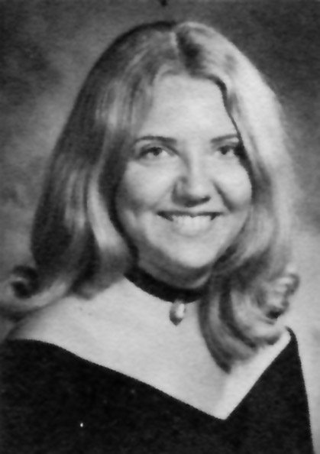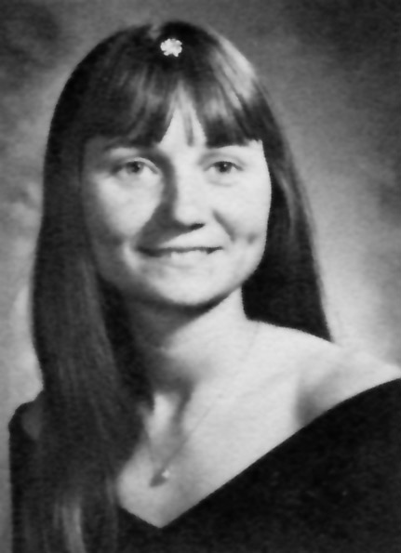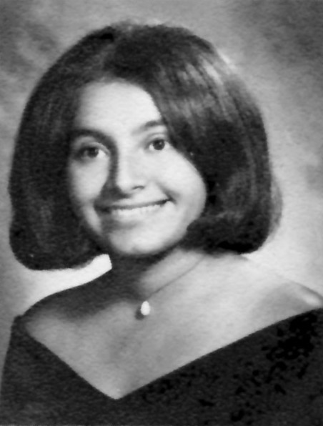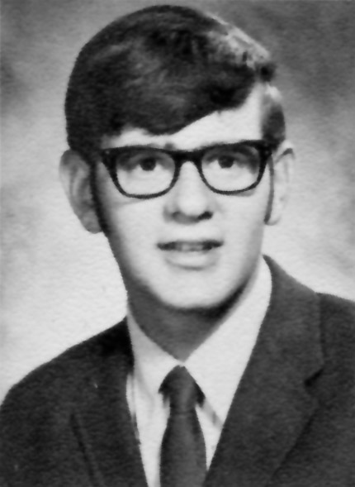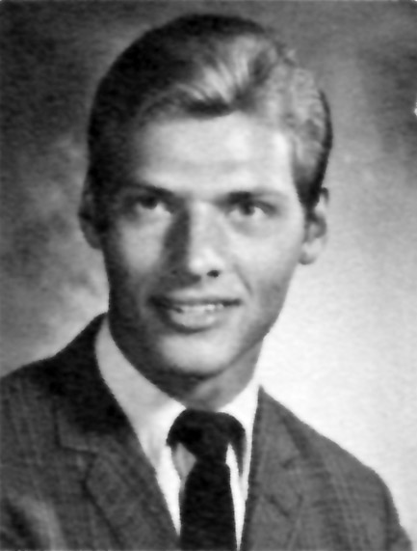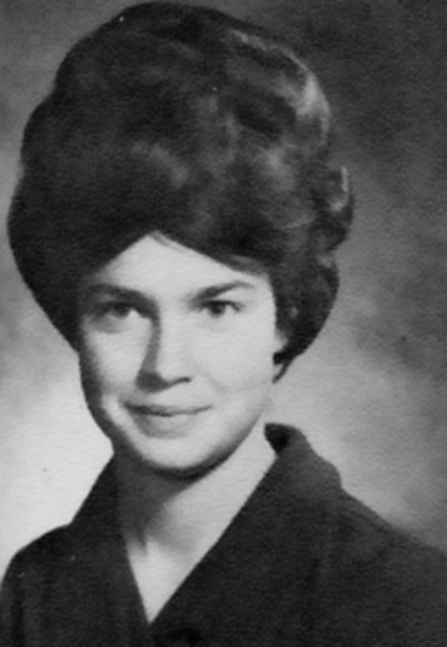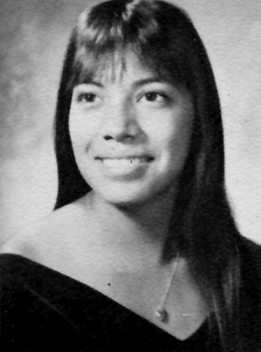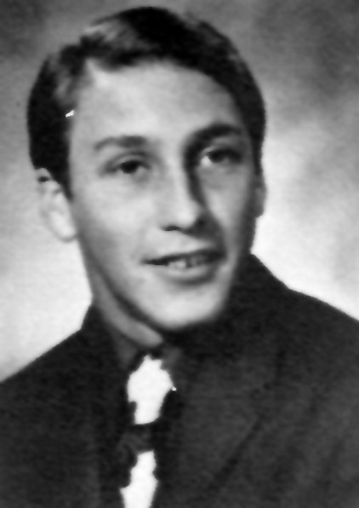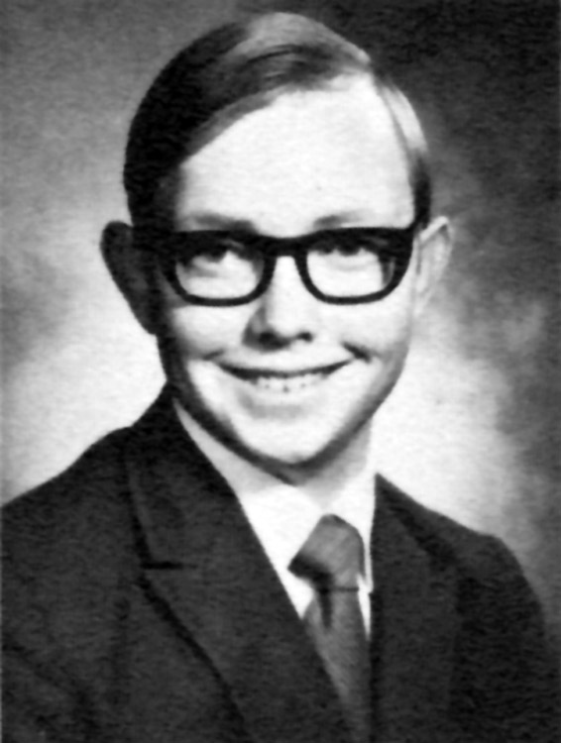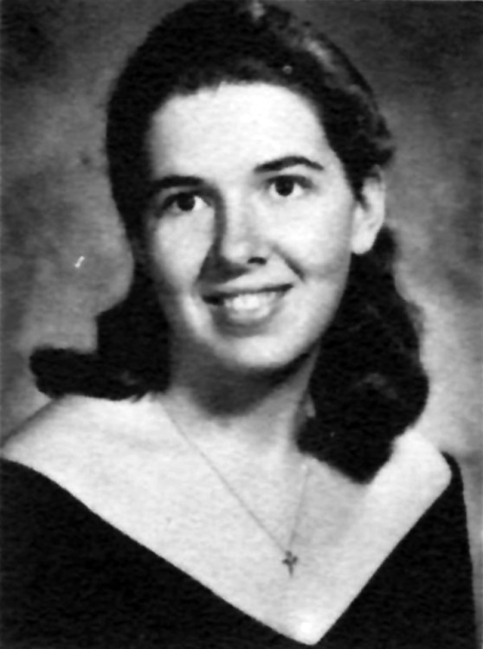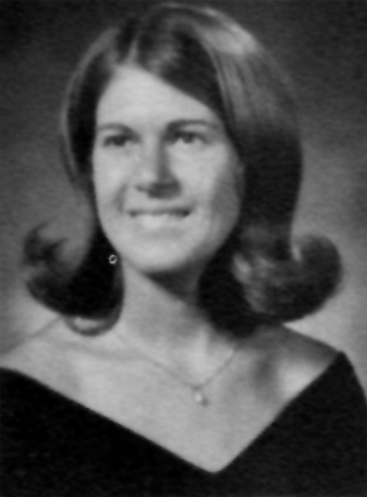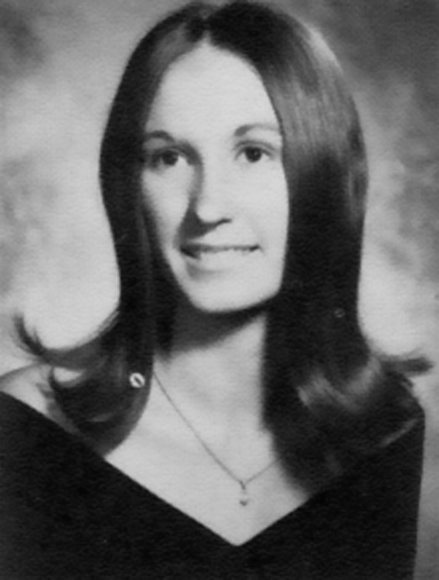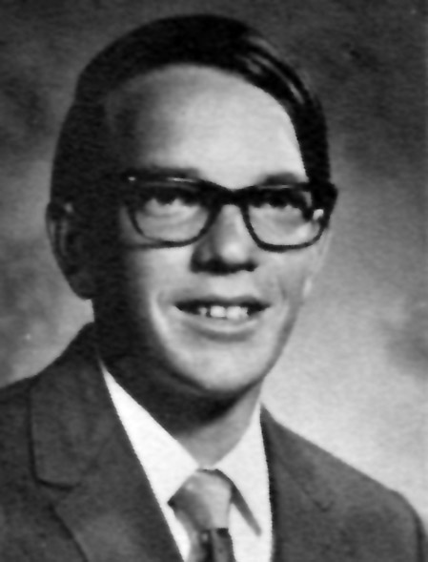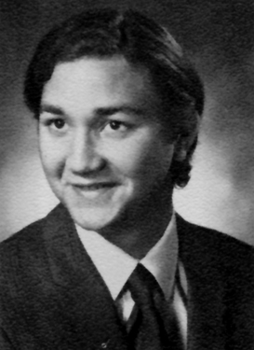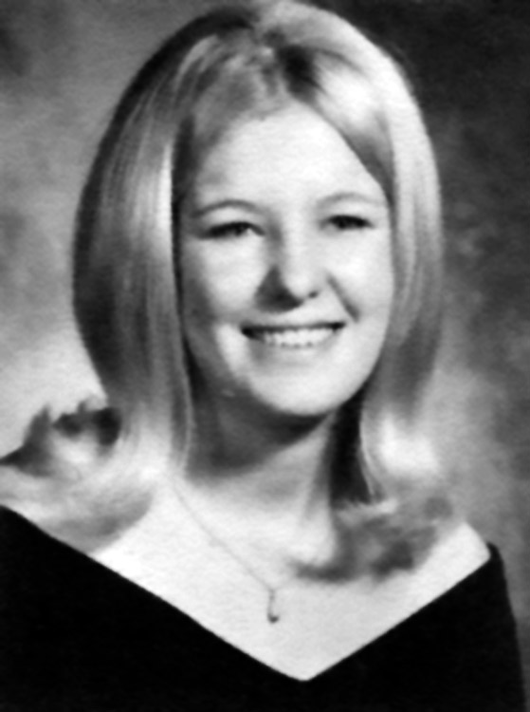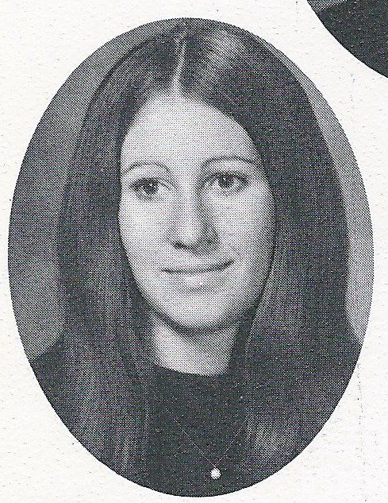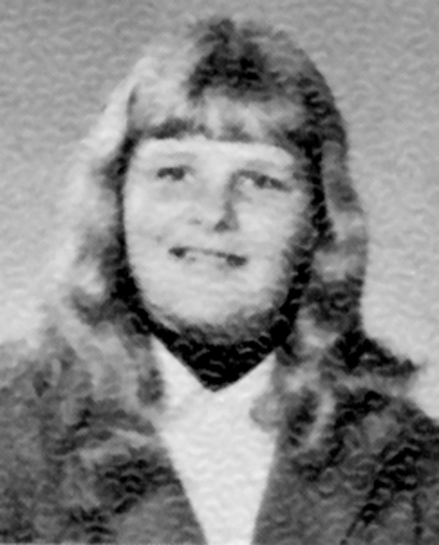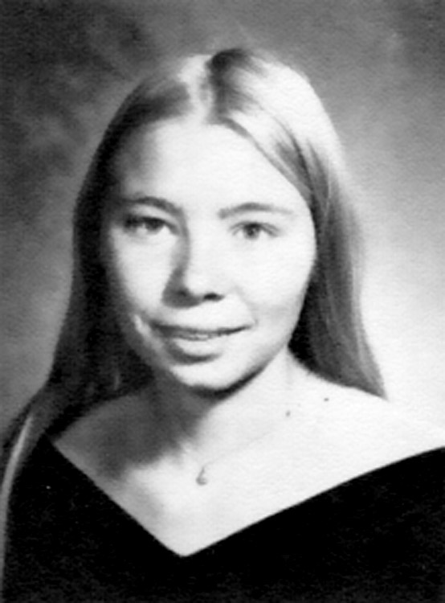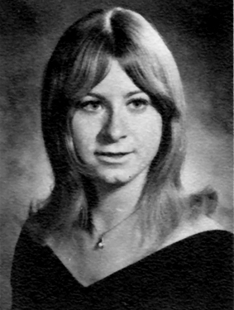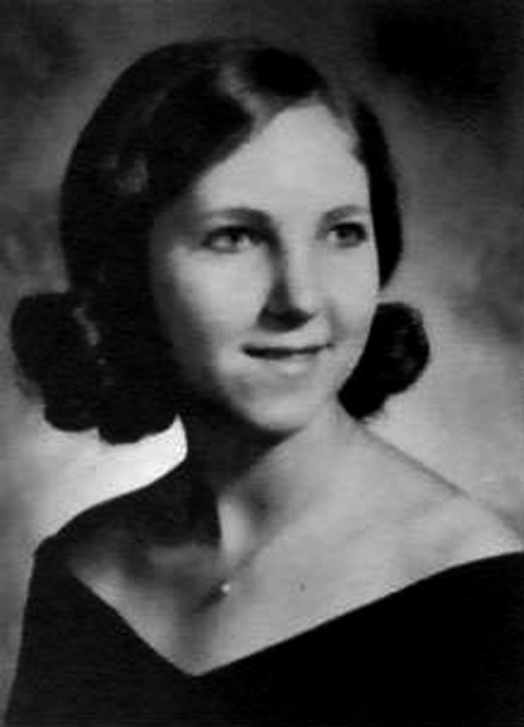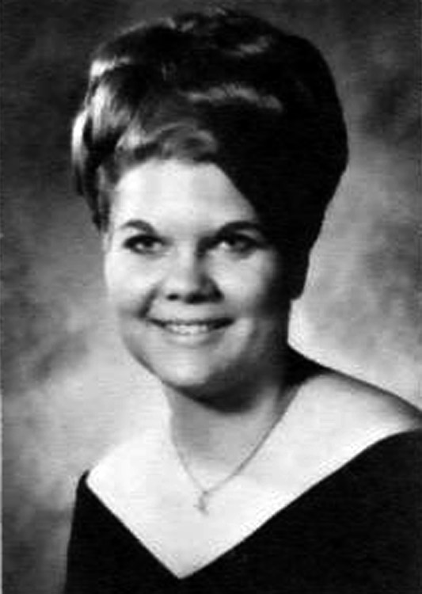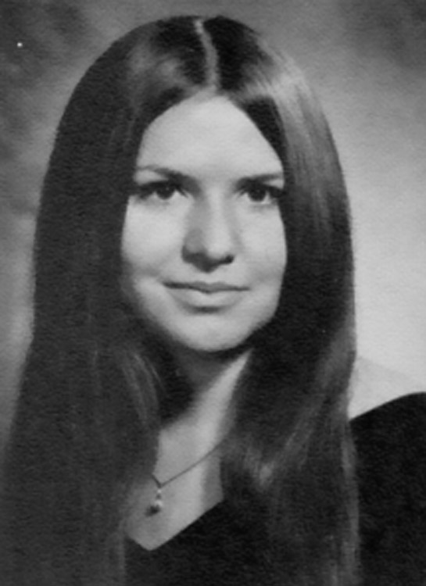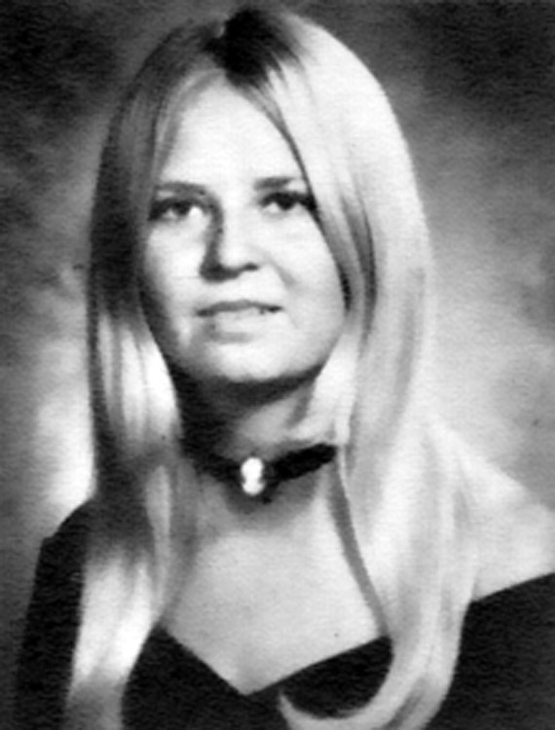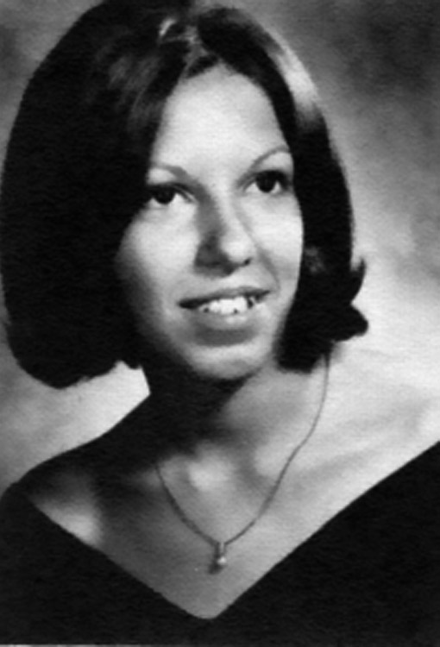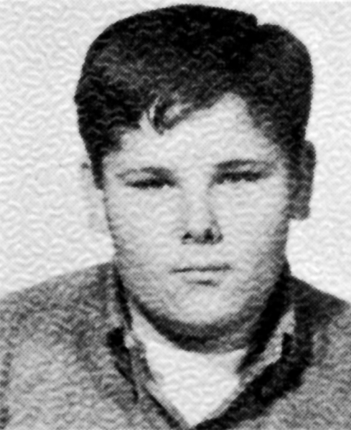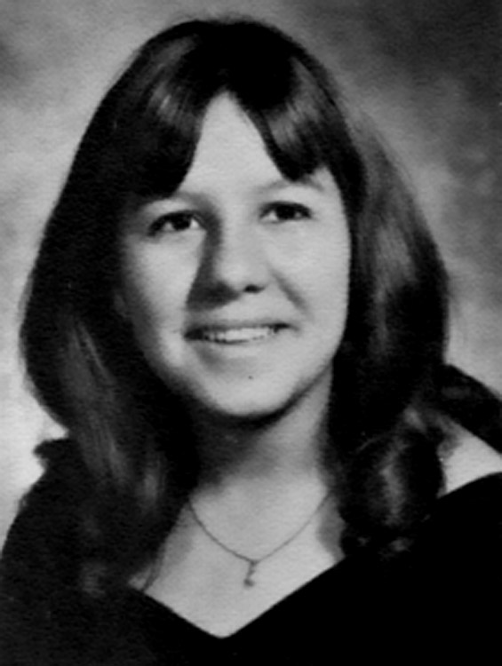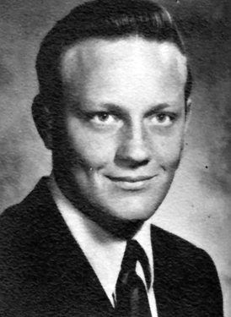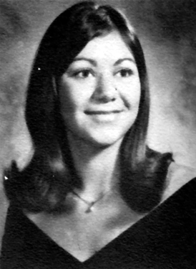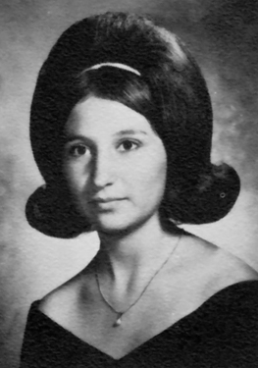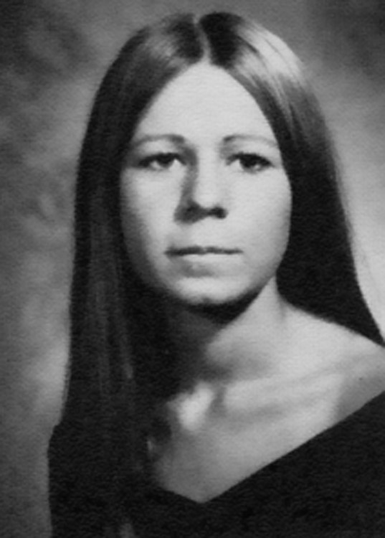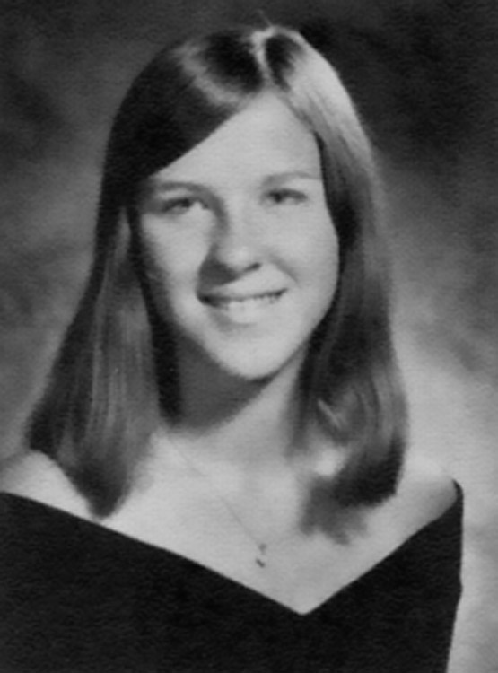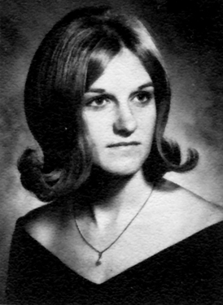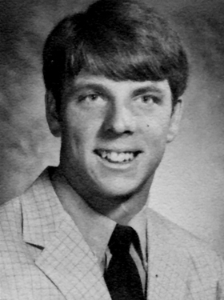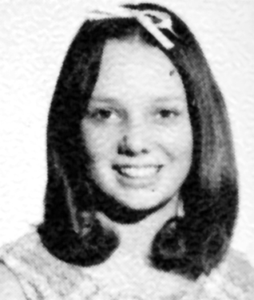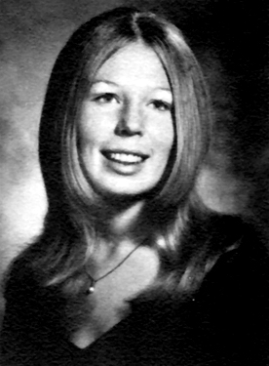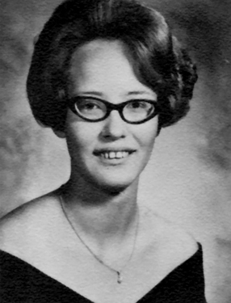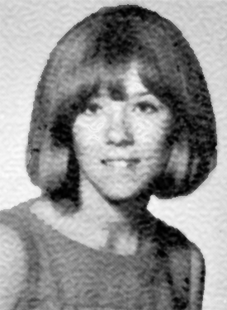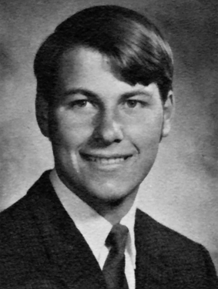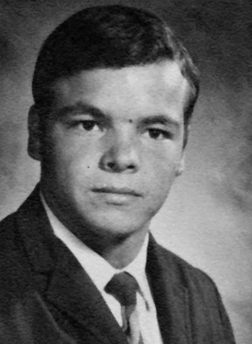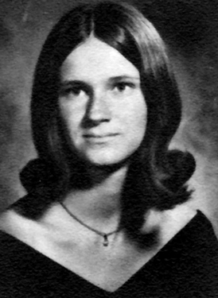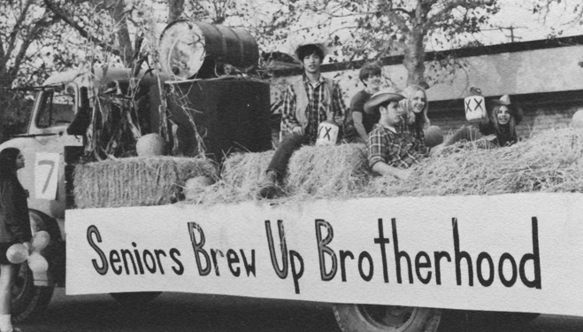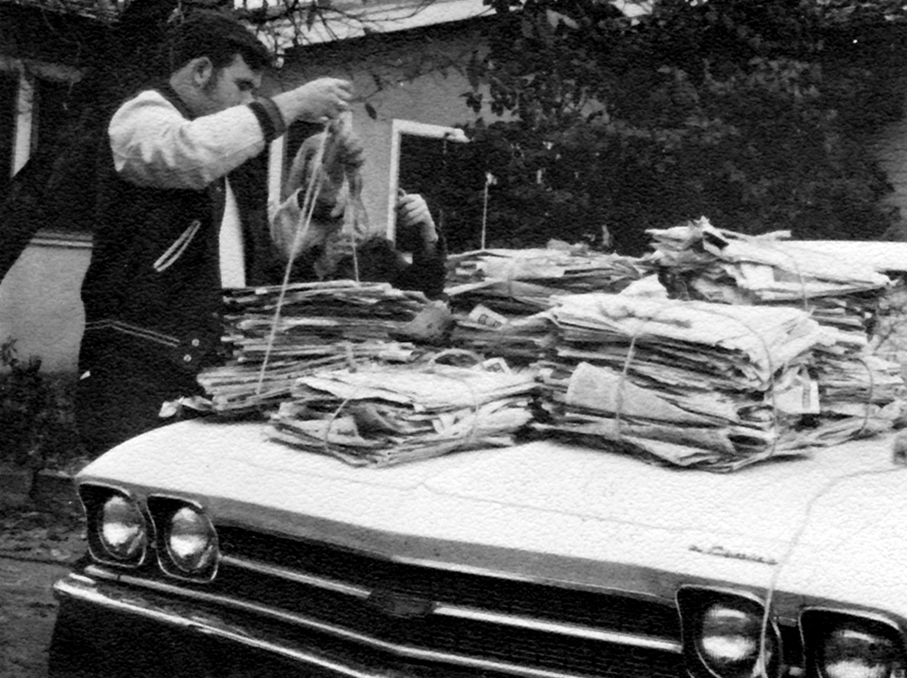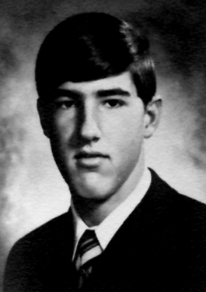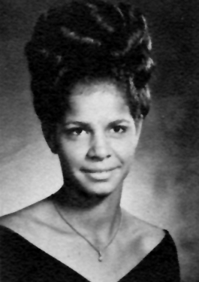

New friends are silver, but old are gold!

Dave and I recently celebrated our 13th anniversary by taking an Alaskan cruise with a little visit to Denali. Since I am still employed as a teacher our travels are usually short (10 days is a long vacation for us) trips during the summer.

I have 2 sons and we have beautiful grandchildren who are growing up so quickly. Our oldest grandson is a sophomore this year.

Have been married to my husband Paul Young for 20 yrs. now.

I have two boys and a daughter from my first marriage. Have 3 step sons and two grandkids with my husband. Have 13 grandchildren and two great-grandchildren. They are my life.

My husband retired 7 yrs. ago and we moved to Michigan where my sons were already living. We would visit them every summer and my husband wanted to retire here so we did. I took a job at Bohning Archery, where we made archery accessories. Loved working there.

Had a stroke 2 years ago and had to take an early retirement.

I miss all my friends in CA but love living in my small town. Surrounded by Christmas trees and the deer just come up in yard. It's beautiful. Don't know if I'll ever get use to the snow though.

## Byron Duerfeldt

## Susan Edwards Miller

After graduation from MHS, I attended Modesto Junior College for two years.  In 1974, I moved to the Midwest, and for the next five years I married, divorced (after one year) and traveled.  I lived in Chicago and Mesa, AZ, during this time.

In 1979, I returned to Modesto, and was hired by the Modesto Police Department.  For the first few years, I worked the Westside of Modesto, and ran into some of our classmates.  I doubt that they will be attending the reunion though as they have other commitments.  During my years at MPD, I also worked in the Motorcycle Division, DARE, Internal Affairs, and Sergeant in the Patrol Division.

In 1982, I met and married my beautiful wife, and best friend, Brenda.  We had two daughters.  Kaylyn is currently 26 years old, and is in her second year of medical school at Boston University. Lindsay is 24 years old, is a professional dancer with the Salt Lake City Ballet Company.  Both girls are single.

In 2005, I retired from the Modesto Police Department, my final assignment being the supervisor of the Robbery and Homicide Unit during the Scott Peterson murder trial.  Brenda retired at the same time from Stanislaus Union School District, where she worked in special education.

Two days into retirement, we moved to Bend, Oregon, located in central Oregon.  We enjoy the outdoor life, including kayaking, hiking, and touring the country on my motorcycle, a Honda ST 1300.  We just returned from a 2,000 mile trip to Northern British Columbia.

We love it here, although I do not think Oregon is my final resting spot.  It will probably depend on where our girls settle.

I am sorry that I will not be able to attend the reunion.  Some of the greatest memories in my life were during the four years at MHS, and the friendships, and experiences I shared with you.

(Continued on next column …)

## Sharon Dudley Young

Jane Driver Richards (continued)

(Continued on next page …)

Ted already told you about our children.  Aaron 32, Chrissy and Brian 28.  The best of them are our 5 grandchildren Olivia 7 my best little girlfriend, Hunter 6 a handful but Papa can handle him.  Abram and Cody are just starting to be stubborn- headed, they are going to be 3.  The youngest grandchild Trent can do no wrong he's 9 months.  We spend a lot of time with the oldest grandchildren, and we see the rest as much as we can.  I graduated from the MJC nursing program in 1979.  I did not intend on getting pregnant during this time.  but, we were blessed with Aaron in March and I had to work especially hard so I could graduate in June of that same year. Luckily everything came out ok. (including Aaron) I pretty much have been working full-time since then.  I was very fortunate to fall in love with Ted when I did because it took the both of us to raise our family and me work fulltime as a surgical nurse in the operating room.  It has taken a lot of my time away from my family,

But I am trying to make up for it now.  I recently went per diem at work. It is very hard to find oneself after all the time spent at work.  So far I am still searching for a hobby, other than being a grandma.  But if that's all I am that's ok.  I am still working one to three days a week but no longer take calls. That alone is pretty terrific.  The last few years of my career I started to assist in the O.R. Went to school so that I could become a first assist.  That is pretty cool! You get to see it all! WOW! for me. Since

I never had a clue what I wanted to do with myself other than marry Ted and live happily ever after.  We have had a terrific and blessed life we still like each other.  I don't want to spend my time with anyone else but him.  Go figure!! I've been to the doctor and had my head examined but they can't find what's wrong with me other than I'm still in love with my high school sweetheart.

We've taken a few trips, Alaska was pretty awesome we did not go the traditional route we flew there rented a car and took off... totally the way to go.  Saw lots of bears up close and personal. We also went to Hawaii. That was nice also. We've done some state traveling also. I want to do a lot more of that. Now I could get hooked on going traveling throughout the United States. Anyway, life is short so we all better get moving. We go to church here in Modesto. Millcreek is the name of the church.  It is very small but terrific. In case anyone is looking for a home this church is the place to be.  God is good!!  All the time!

## Marlene Gonzales Donham

Gary Gervase (continued)

(Continued on next column …)

1973 - 1990: Christian Youth Minister in Modesto, Brandon Florida and St Paul, Minnesota 1991-1992: Real Estate Appraiser in St Paul Minnesota and Las Vegas Nevada 1993 - 2002: Wireless cell tower industry development - Western US, based out of Modesto 2002 - July 2008: Residential Real Estate at Coldwell Banker Vinson Chase, Modesto CA Aug 2008 - Present: Project Development Manager at enXco Development, Inc. Managing aspects of development for alternative energy, particularly wind energy. Travel frequently for business.

Was married 21 Years, and have two beautiful daughters, Janee age 30 and Jessi age 26 who is the mother of my granddaughter Hallie. Hallie is approaching 3 and a half and is the best part of my life. Been single for 16 or 17 years, but spend a lot of time still with my kids (who are adult, successful women) and especially my granddaughter, who is my best buddy! My daughters are sort of angry and bitter because I like her more than them!

I had the pleasure of coordinating our 35th reunion with Patty Amador, Mike Hewitt, Julie Miller, Sandi Price and Tom Dick along with the assistance of several others.

Love to play golf and still have played music up until this year. Had about 4 bands since moving back to Modesto in '93, but most of that time was with Fat Man Blues Band that I started in '93 with MHS alumni Michael Hewitt and Rick Serna and two other guys. My next project is in the works.

Got to fly over Mt. St. Helens a week after it blew up... Got to stand in front of the gates at Graceland the day Elvis was buried... Prince's original guitar player - Dez Dickerson - played lead guitar in one of my Minneapolis bands - although he might not want that to be public knowledge... Got to meet the Rev. Billy Graham...

Many know that I am adopted, but I found out at age 50 that I have no Italian in me and I am, apparently half Mexican...!

Got to sing the National Anthem in front of an estimated 20,000 plus on the Fourth of July before the fireworks - with 20 minutes notice...! Got to play the Calgary Stampede - twice... Got to have lunch and a beer with Tommy Lee Jones the actor on his ranch in middle-of-nowhere Texas... One of my three best friends from High School - Les Hughey - is still one of my three best friends in the world, although we don't see each other as much as we like. Perhaps the world is a safer place...!

Life is good and God is good!

## Gary Gervase

Was in the construction industry for many years. Subcontractor in Washington state for 10 years then moved back to California to help my mother out after my fathers death. I have been in the Modesto area now since 2002. I am divorced and have a daughter now 32 years old and a granddaughter 9 months old. Currently in sales for a company called Maintenance Engineering as an independent sales rep selling industrial lighting. I live alone unless you count my two little dogs, Skittle, a part Shih Tzu, and Foxy, a little part Pomeranian with predominantly black but with white on her chest and patches of brown on her ears and feet. Since my parents were the youngest in their family, my family is gone, including cousins and second cousins. My younger brother died April 24, 2010. My other brother and my mother live in Mississippi. I'll turn 59 on September 2nd. Wow! Just a few more days.

## Brad Gallagher

Worked for Memorial Hospital for 21 years. I have three children and nine grandchildren, but no great grandchildren. Two granddaughters are in college. I travel… road trips (Oklahoma, Arkansas) and cruises. I want to retire next year … that’s my goal. I have a friend and traveling companion, Ron Monk.

## Rachel Enney

The best antiques to collect are old friends

## Michael Groves

Left Modesto in 1972; went to Colorado Springs for a while, then to Auburn University to begin a campus ministry (Navigators). Graduated with BS in Secondary Education from Auburn in 1979; returned to Denver and worked for Ball Metal Container Group. Married Leah Davis in 1980.

Left Denver to enter Covenant Theological Seminary in 1981. Graduated with a Master of Divinity in 1984. Also had our first son Jonathan in 1984. Moved to Houston, Texas as Associate Pastor of Spring Cypress Presbyterian Church in 1984. Started Northwest Presbyterian Church in Houston in 1985 and pastored until 1990. Also had a daughter, Laura, in 1987. Returned to Spring Cypress as an Associate Pastor in 1990 and started working on my doctorate. I am ABD (all but dissertation). Our third child, Rebecca, was born in 1992.

In 1995 we moved to Corpus Christ, Texas. I was Senior Pastor of Southside Community Church for 11 years. During those years I also taught at a private Christian school. In 2005 my son was married. I'm now the proud grandfather of two grandsons, Nathan and Aaron.

In 2006 I left the ministry and moved to Alaska to work in my father's business. I've been Vice-President and General Manager of WesGro Paint & Drywall Supply, Inc. since December of 2006.

In 2007 I divorced and remarried to Kathy Gilley Antonetz. She is a Registered Nurse, CDE, and CPN. In December of 2009 Kathy was diagnosed with Ovarian Cancer. That has ruled our world since. Her last two scans were stable, so we are still battling.

WesGro is being sold to SBS/ProBuild. I will soon be working for ProBuild as a Client Sales Rep. In September we are visiting our family, children, and grandchildren in Corpus Christi. Kathy has two older sons from her first marriage.

Hope I didn't overdo it. We would love to celebrate and visit with you in October, but can't. I miss you all and those distant high school years. Have fun!!!

I am married with two children, three stepchildren and eleven grandchildren (between my husband Ray and myself). I live in Modesto and am a teacher with Modesto City Schools. And I am really trying hard to lose weight for this reunion!

## Rachel Gonzales

Marlene Gonzales Donham (continued)

After high school, I attended MJC and was very active in the drama department both as a student and as a theater tech. After MJC I started at CSU, Stanislaus, but dropped after one semester to work full time. I spent a few years working in a small grocery store, learned to be a meat cutter and eventually changed to a union job for a wholesale meat company supplying restaurants and hospitals. Looking for a change I worked in sales for a few years, first for a Mexican food company and then in wine and spirits distribution.

   After 10 year in the labor force I returned to CSU,S and got my BA in English and a teaching credential. I've been teaching in HIlmar for 24 years ... 16 at the high school and the last eight at the continuation high school. I earned my Masters in Administration and Supervision in 2006 and am looking forward to the chance to be the principal at my school in the near future (if all goes right!).

  I was married for 15 years, but have been single for the last 16 years. I have a daughter, Robyn, who is 27 and a special education teacher in Los Banos, and a son, Scott, who is 23 and a student at MJC.

  I enjoy watching baseball (Go Giants!), riding my motorcycle (I've made two cross-country trips), playing music in blues bands (Fat Man Blues Band, Whitey Slim), fly fishing (Sierras, Alaska, Montana), and reading (too many authors to mention). Over the years I've also continued to stay active in theater performing with MJC, Central Valley Players, Modesto Civic Theater, and recently, the Prospect Theater Company.

(Continued on next page …)

## Michael Hewitt

My husband, John, (married 30 years this year) and I have two beautiful daughters, Liberty and Melody.  Liberty is a 6th grade social studies teacher in Little Rock, AR.  Melody is living in Los Angeles, California and is pursuing her passion in communications.  Both are warm loving individuals.  John suffered an industrial disability and now stays home and cares for us all.  I continue to work in Cardiology at St. Joseph's Medical Center in Stockton, California.  Two years ago I traveled on a Mission Trip to Malawi, Africa.  It was a life-changing sojourn that renewed my faith and fueled my passion for service.  We are rich in resources, but richer in opportunity, and that is the message I carry.

## Manzanita Hensely Lowarch

Alice Gwerder Rowe (continued)

After MHS and MJC, I got my B.S. in Nursing from San Jose State.  It was there that I met and married my husband of 36 years, Fred Rowe.  He attended UCSD Medical School, and together we lived in San Diego, Portland (Internship), and Fresno (Emergency Medicine Residency).  While in Fresno, I got my Masters Degree in Nursing. After training was complete, we moved to Sacramento, where we have settled for the past 26 years.  We have two sons, ages 25 and 22, both of which live in the Bay Area.  Neither is married yet.  Over the years, my husband I have taken many trips, including a six-month adventure that took us to Egypt, Kenya, Israel, Turkey and most of Europe.  We have also traveled throughout the US and have vacationed in Hong Kong, Mexico and Canada. We have participated in two service trips, working in Ecuador and Romania. My husband is now retired and we plan to travel more in the future. We are also both members of our local Rotary Club and we both do a lot of volunteering.

(Continued on next column …)

## Alice Gwerder Rowe

We will be married 40 years this coming December.  Joe retired as a Senior Chief Petty Officer in the U.S. Coast Guard in 1993 after 20 years of service.  His work has taken him to many different places in the world along with Diana.  After retirement we moved to Reno, Nevada where we resided for 8 years where Joe worked for the State of Nevada DOT.

While in the Coast Guard, Diana managed an Office Supply store in Kodiak, Alaska.  In 1983, she started her career in the financial industry with Merrill Lynch, and with the exception of the 8 years in Reno, where she worked for A.G. Edwards and Smith Barney, she continues to work with Merrill Lynch, now over 20 years as a Senior Registered Associate.

We now live in Modesto, where Joe now works for Modesto City Schools as a Campus Supervisor at Roosevelt Junior High School. Our son is working toward his Bachelor's Degree in Leadership Management through Oklahoma University, while at the same time making a career out of the U.S. Coast Guard as a Senior Chief Petty Officer (Silver Badge) stationed in Charleston, S.C.  Our daughter-in-law Antreka works as a GS-9 on the Coast Guard base in Charleston.  We have a 20-year-old granddaughter named Maddie who is attending San Diego State University.  Our two grandsons, Cody, 13 and Oliver, 9, are what most grandparents say, simply the best.

## Larry Joe & Diana Riley Gunkel

(Continued on next page …)

Hello to everyone! I'm so happy there's a site like Facebook where people can re-connect. Bio-wise, I'm still married to my second wife, Cyndi, and between us we have 7 kids and 16 (at last count) grandchildren. My children's names are (yes, I claim them all!): Tonya, Melanie, Charity, David, Matthew, Andrew and Zachary. I'm so proud of all they've accomplished and achieved. Tonya is a stay-at-home mom that wants to go back to teaching, Melanie works in private security and was recently recognized for saving a man's life, Charity owns a major sign company in Modesto, Visual Horizons Custom Signs, David is Director of Audio/Visual for Hyatt Regency, Matthew served two tours of duty in Iraq and Afghanistan and is disabled due to injuries, Andrew is a comic book artist for DC comics and whose work can recently be seen in the latest issue of Superboy, and Zachary, the youngest, who graduated from Beyer H.S. in 2000 and was back there teaching in 2005 (now at Enochs).

I've been in dialysis for over 35 years, professionally interacting with many people from our area, sometimes it's people I went to school with, or their parents, sometimes with well known people who have had parks named after them or who own some of the finest restaurants, and sometimes it's simply the forgotten. For me, dialysis pays the bills but my real passion is reaching the lost. I came to the realization a long time ago that once you are a created soul you will live eternally somewhere and I've accepted that challenge from God to help others find that truth. For more info on the miracles I've seen and the lives I've seen changed, feel free to contact me. To all my classmates, thank you for being a part of my life. Now, join me in God's family and make Jesus Lord & Savior of your life! Hope to see you there (Heaven)!

## David Kopecki

I am still married to my high school sweetheart, Ronnie Allen.  Married 40 years, we have a daughter, Rene' (37) and son Ronnie Jr (35)...5 grandchildren (4 girls ages 18,13,6,4 and 1 grandson age 16).  Moved to Arkansas 1990 and love it!  I am a Realtor and Ron has his own home inspection business.  We are very active in our church (Ron is a Deacon) and stay busy with our grandchildren.  We miss our friends and family in the Modesto area, but love our life in Arkansas.  I would love to hear from our classmates....I am on Facebook and have a Realtor website [http://debyallen.crye-leike.com](http://debyallen.crye-leike.com/).  Let's catch up!!

## Deby James Allen

Married my high school sweetheart in Sept. right after high school.

We moved to San Jose as he was going to college there.  I went to San Jose City College.  Left there after a couple of yrs and headed to Sacramento where our first child was born.  Moved back to Modesto in few more short yrs.  Second child was born here.  Worked at American National Bank on 5th Street and Mc Henry.  I went to work for Safe-T-Lite as a bookkeeper and stayed there for 21 yrs.  My husband worked for Stanislaus Co for 33 yrs and retired, so I did too.

We have had some wonderful yrs traveling in Europe for a month at a time, renting a car and driving the back roads.  Laughing the whole time as we tried not to get killed as we learned to drive on the side opposite of our nature.  Have been back in Modesto for 33 yrs now and I love Modesto.  We are happy and have five grandchildren

## Shirley Jackson Turner

I have been a widow for 6sixyears.  My husband Tom and I were married for 33 years.  I have one daughter, Blondie, and two sons, JR and Donnie.  I also have four grandchildren and two great grandchildren.

Tom and I spent a lot of our spare time restoring old vehicles, camping and fishing. I still love to camp and fish and do as much of it as I can.

## Debby Hodge

Michael Hewitt (continued)

Life gives us brief moments with one another... but sometimes in those brief moments we get memories that last a lifetime...

I moved to Sapulpa, OK 10 yrs ago to be near my niece and family and she moved back to California. I quit working in the nursing home business after 20 yrs and now I am an assistant manager in a deli in the mall. I live with my long time companion, Steve, of 30 yrs. I never married and have no children, but I spoil everyone else's. I have 2 great-nieces and 3 great-nephews.

I am a member of Bikers Against Child Abuse and help them put on fundraisers and collect donations, .so if anyone needs ideas to raise money just ask. I do pretty good at getting an event put together with zero expense so we have 100% profit.

I do quilting and read when I can, but working two jobs keeps me pretty busy. My sister Liz lives nearby so I do have family here. Guy lives in Modesto and has one son. They put on a destruction derby in the area and have Moon's Halloween Bash coming up soon.

As I just flew out to California in June, I won't be able to attend, but will keep everyone in my thoughts and hope you have a great time together. I will be attending a Dolly Parton concert that evening. I love the Facebook page. Great to talk to everyone. Hope more classmates join in and we can catch up on their lives.

## Gail Mullins

I am engaged to Glenn Rehder for three years and have two wonderful girls.  My oldest is married and I have a beautiful grandson, Gabriel, who will be two in October. My pride and joy.  I am still working at Raley's, 21 yrs now,  in Oakdale, CA. I am still the deli manager and love it.  I have been to Hawaii and Puerta Vallarta, and Acapulco but when I can would love to travel to Europe and England.  My dream someday, lol. I love to landscape and garden and home decorate on the side, which keeps me really busy!

## Kim Marlin

Hello classmates. To make a really long story - short, i am divorced and have 4 kids. 3 boys and 1 girl. That would be my greatest accomplishment in life. The road has not been easy raising them alone, but we did it. I am very proud of them all. My oldest son was in a horrible accident right after he turned18 and has been in a wheelchair every since. I don’t know how, but he still has a happy heart. My second son has three sons of his own and lives in Missouri. Son number 3 is an engineer at Gallo. My baby girl, now 26, is an RN and lives in Visalia. I have been working in the Accounting office at Memorial Medical Center for 13 years now. Last year I found one of my best friends from MHS on Facebook. It was awesome to reconnect with Billie Vires after such a long time. I don’t think we will lose that again. I am both a little apprehensive and anxious to see "the kids" from MHS '71. See you all soon.

## Lisa Lynch Lee

After high school I continued my education in health care. I became a Respiratory Therapist. In 1983 I met and married Fred a Pata (from Downey High) Some of you know him from grade school. Anyway, we have been married 28 years. We have 1 adopted daughter, Sara and 1 granddaughter, Savannah. In 2005 I had to stop working do to a disability. I now have to use a scooter or wheelchair for mobility. I miss not working because it was what I did for over 38 years. But now,it is what it is and every day I wake up it is a good day.

## Darlene Long Pata

David Kopecki (continued)

I count myself in nothing else so happy as in a soul rememb'ring my good friends. - William Shakespeare

(Continued on next page …)

I've been living in Southern Oregon since 1994. I currently live in the Applegate Valley on 5 acres near the Applegate River just outside of the small town of Jacksonville, OR.  I have been employed as a Speech/Language Pathologist since 1976 (right after grad school) for a variety of school districts and in private practice. I still love my work! I am currently employed by Central Point School District.

I am married to a wonderful guy, Rick Taylor, who is a middle school language arts teacher. I am glad there are people like Rick who are willing to brave the middle school and enjoy the work!

We have a bright, beautiful 16-year-old daughter, Ali, who is a high school sophomore. We love to travel. Our daughter has grown up with memories of trudging through foreign lands carrying her little backpack. The backpack is now bigger and she loves to travel.  The last trip was to Portugal. Ali is currently interested in photojournalism, so who knows where that might take her.

We have horses that my daughter and I love to ride. My husband rides a horse on occasion, but he prefers his racing recumbent road bike and his bike group who hammer hard. We have been blessed with good health and much happiness. We are working hard to stay fit and active as age advances!  We continue to try to keep our lives in balance and our perspective on what is really important as we live in the moment.

## Barbara Reeves Taylor

Hi everyone.  Wow, forty years, can that be right?  It will be interesting to see what former classmates have been up to.  I married Dave Silva (Turlock High class of 71) in 2006 and am now living and enjoying the country life. My two sons, Aaron (32) and Derek (25) are doing well and both still live in the Turlock area. With my marriage, I gained a friend and stepdaughter Stacy.  She and her husband Jeremy recently had a daughter, Sydney. Dave and I are having so much fun with our adorable one-year-old granddaughter. I am still employed (24 years) at the same electrical company.  Yes, still checking shorts. I stay busy and happy with our family, friends, almond orchards, work, play, and travel. I have to say that at this point, life is good!

## Sandra Price Silva

I've had several "careers" since graduating. The last and longest was in medical billing. I retired from Tenet healthcare in 1999 at the ripe old age of 46. Since then I have become a grandma two times and enjoy spending lots of time with two beautiful little girls every chance I get. My husband also retired in 1999 and is a consultant. We love to visit the central coast but don't get away often enough. I'm looking forward to renewing friendships at our 40th reunion.

## Peggy Patton Hegel

I am married to Marilyn Petty Parman, a fellow alumni graduated in 1970. We just celebrated 41 years of marriage in June 2011. We have two children, Kevin (Glena) and Jennifer (Matt), but only one grandchild, Shawn Giles Parman. Shawn lives with his parents in the house across our back fence so as you can imagine we are very hands on grandparents.

Marilyn and I both worked at the Post Cereal/ Kool-Aid facility and retired four years ago after 35 years of service. We both enjoy genealogy as a hobby so we spend some time on the road tracing our numerous family trees, as well as volunteering for the Web Site Find-A-Grave tracing down headstones and taking pictures.

I enjoy reading all about the lives of everyone I went to school with. I have to say my memories of high school are limited as my stay wasn't the full four years. I graduated mid-term 71 and my senior year I had only two classes, auto-mechanics and gym. I actually had enough credits to graduate with the ‘70 class except for some clerical error brought me back. Shortly after the school year started, they corrected it ,but then would not let me out of attending.

## Doug Parman

Hello, I have two children (Connie 37 & Jesus (33) One grandson (Dominic 3 yrs).

I am a Project Manager for Clinica Sierra Vista which are Federally Qualified Health Centers (Health, Behavorial Health and Dental Clinics).  I do credentialing for Providers.  I have lived in Bakersfield for 22 years.

I spend lots of time with my Grandson and work full time.  Enjoy the beach and spending time with family and friends.

.

## Sandra Najera Lopez

Nothing is as comfortable as an old friend

I am still madly in love with my MHS sweetheart and wife Kathy. Next June will be our 40th. We have 4 kids and 2 grandkids. Our youngest is 16 and our oldest is 35.(wow) I worked 34 years for a plastics company in Modesto and Fresno. We semi-retired and moved to Missouri in ‘06 and have been here ever since. This year my old company opened a new facility here so I am running it for them. The rest of my time is spent fishing, hunting and spending quality time with my wife.

## Randy Scott

I had been working in the medical field for the past 35 years until a near-fatal car accident in Oregon in 2005! I was in a coma for 3 weeks (!), but made it thru!!! Truly a miracle!!! Came away with lots of injuries, but I'm doing well!! Unfortunately------I have been on medical disability ever since!  I have 2 wonderful sons & 3 grandsons with another grandson on the way!! I am currently single, still living in NORTHERN California in beautiful----REDDING!! for nearly 30 years now!! I love it up here!!

## Rosemary Samuelson

I'm still married to my husband of 40 years; daughter, Katherine (one-granddaughter (12 years) and 3 grandsons, (9, 7 and 7 months), son, Dominic (one grandson, 2 months old). We all live close to each other in the Modesto area. We have played Friday nights co-ed softball through Modesto Parks and Recreation department for many years; a way to keep the family together! Currently, we divide our time between work and grandchildren's sports: soccer, softball, and baseball.

I have worked at Stanislaus County Office of Education for the past 11 years as a Staff Assistant for Information Technology and Network Services departments; previously, had worked for The Modesto Bee for 19 years as a newsroom assistant!

I spent six weeks in New Mexico assisting with the election of Barack Obama turning New Mexico into a democratic state after 19 years of a republican run leadership. I was able to be part of this historical event through my union involvement, which I serve as secretary for classified employees.

If I am not doing union work or attending my grandchildren's sports activities, you can find me at a casino, spending my grandchildren's inheritance...lol!

## Ruth Saldana Gloria

Single, with 3 children and 3 grandchildren.  Worked for Costco Wholesale since 1993. Lived in Kona on the Big Island of Hawaii for 12 years. Returned to Modesto for family reasons and have been raising my nephew who has special needs for the last 10 years. It's been amazing connecting with all these people. Some I have known since Kindergarten at Washington Elementary School, James Marshall, Mark Twain Jr. High, and the greatest of all, "MHS" CLASS OF '71

## Hazel Roman Naymon

I’ve been married for 37 years and have two children, Matthew, MHS class of 96 and Ashley, MHS class of 02....I have three grandchildren from my son, Michaela, 9 Alie, 4 and Thomas, 2....

I live out in the country and we farm almonds.... Have some cows too....

I've been working at Trader Joe's for almost 3 years now and enjoy it...

I've been fortunate that my aunt has taken me on trips to China, Egypt and Greece...I would love to travel more if I could...

## Pamela Rettig Dubbs

Barbara Reeves Taylor (continued)

(Continued on next page …)

Good friends are hard to find, harder to leave, and impossible to forget

I work for Don's Mobile Glass in the Administration Office in A/P and I've been there for 22 years. My daughter works @ Rose Ave. school as yard duty, she has 3 children, and my son works for Cal Trans, and he also has 3 children and 2 stepchildren. I guess you could say I have 8 grandchildren in all, and it is very hectic at holidays since we spend all holidays at grandma and grandpa's house. I enjoy trips to Tahoe and reading and relaxing at home when I am not spending time playing badminton and basketball with the kids.

## Brenda Tennis

Married Linda in 1973. Have 3 children, Andrea, Allison, and Greg, and 4 grandchildren, 3 boys 1 girl. I do maintenance and custodial and am a bus driver for Ripon Unified. Linda is a sales rep for Protech Security. I travel the western states as a tire specialist for Bill McAnally. The race.driver is Eric Holmes, 3x champion. Busy with life!

## Art Streeter

I've been married to my high school sweetheart for 41 yrs. We have two daughters and three grandchildren. We are both doing well. My husband Michael from Downey H.S. retired from CA state service in 2008. I've been working for the state also and have five years before I retire. We moved from Modesto to Ripon in 1996 where we built our home. We both enjoy cooking and working together around our place. My husband sings with the Golden Valley Chorus in Turlock and the American River Chorus in Sacramento. I enjoy gardening and being outdoors. We also like taking long drives to visit with our grandchildren. God has truly blessed our lives.

## Gail Singleton Boyd

Happily married to Rick Avana. I have 2 boys, Jesse 29, and Levon 26. I am retired now and so is Rick. I have no grandchildren yet from my sons, but have 3 (almost 4) from Rick's daughter, Deja, who is due at the end of this year.  Life is really good and getting better everyday.

Now that Rick and I are retired, we plan to do some traveling.  We haven't really done much of anything since we've been married except work. Since we no longer have any kids living at home, we can go an do what pleases us both.  I do have an eBay business, which is a lot of fun and can be very profitable at times.

    I have always loved music whether I'm playing or just listening to it at a concert or a club.  I've been a player since the 3rd. grade all the way through high school, and for the last decade or so, I have been singing and playing in a blues band here locally. The thing about music is that it can do so many things for you. It can make your world brighter when you need it the most. But most importantly, it reaches everybody and affects you in a positive way.  Its an important element in my life, and I encourage those of you who still play to keep it up.

## Carolyn Shelton Avana

Married twice with two boys and two grandsons.  I have pretty much stayed here in Modesto/Ceres area.  I work with the Stanislaus County Office of Education Graphic Services and have been there 26 years.  I have been to a lot of places in the last umpteen years but my greatest adventure was three years ago, I went to South Africa on a missions trip with my church to help restore living quarters for a Bible college.  It changed my life.

## Sandra Sexton

Randy Scott (continued)

True terror is to wake up one morning and discover that your high school class is running the country. - Kurt Vonnegut

I have been married to Randy Boyd for over 26 years.  When we got married we each had 6-year-old sons from our previous marriages that we raised together, Daniel and Devon. They have both brought beautiful (inside and out) women into our family.  Daniel is married to Laura and Devon is married to Tess.

I still work for Ceres Unified (26 years) as a secretary in the Transportation Dept. Randy works for Stanislaus County Office of Ed. as the Supervisor of Custodians and Grounds. I am looking forward to an early retirement in a couple of years, at least that is what I am aiming for.

We have traveled around the United States. Randy had to visit his native Scotland with friends as I have no urge to go overseas. Our favorite trip so far was to Niagara Falls and Toronto. We hope to do a lot of traveling when we retire.

Something I have learned is how wickedly awesome grandchildren are.  They are the joys of my and Randy's life. Daniel and Laura have a 3-year-old princess named Lyla and a 5-month-old baby boy named Tegan.  Devon and Tess have a 12-year-old son named Inteus (goes by Taber) and a 9-year-old son named Aydan. Randy loves to teach his grand kids all about the great artists of the world, such as KISS, Beatles, etc.! I just love to spoil them.

To quote The Grateful Dead..."What a long, strange trip it's been." Through good times & bad the one thing that did not change is who I am inside. And you all played a part in helping me to become who I am. We all grew up together becoming the people we were meant to be. I do hope that we all became the kind of people who are strong enough to withstand what ever comes our way and to be joyous enough to embrace all the blessings that come with each new day.

One thing I am grateful for is the courage to do the things in life I wanted to experience. Whether it was moving to LA by myself at age 22 to study screen writing or moving back to Modesto to put on horse events, I have always enjoyed the journey.

But the cherry on top for me was reuniting with my high school sweetheart. Tom and I have been together for 10 years now and every day spent with him is a true blessing.

So, Dear Class of 1971, I hope to see you all soon.  We have come a long way and I do hope the road is smooth and the wind is at our backs. Be good, take care and much love & light to you all. And let's keep "rockin' in a free world."

## Paula Wooten Aragon

I retired in 2007 from the Modesto Irrigation District after 35 years.  I have been married for 37 years to Connie Burtis Williams (class of 1972).  We have 2 daughters and 1 grandson.  I get lots of "help" from my grandson on projects around the house.  We do daycare for him while his parents work.  I raise English parakeets and travel the state showing them.  I have been a fan of college football forever and especially enjoy the Fighting Irish of Norte Dame.

## Kenny Williams

I am not married, but have two X-wives. I have five children and three grandchildren.

I was a laser service tech. I worked on small lasers to 2.5kw. I went all over the USA fixing lasers. I did that for about 27 years. I started getting real bad head problems and had to give laser up for good.

I am now getting a VA pension and not doing much any more

## Bruce Westfall

## Billie Vires Boyd

After high school I worked for several companies, including Bordens and Moore Business Forms. I eventually went to work for Racor Industries and worked my way up through manufacturing and quality control before moving into sales. I left Racor to work for Donaldson Corporation for a while, but returned to Racor and it’s parent company, Parker Hannifin where I remained until a few years ago when I began working for another Parker subsidiary, Village Marine. Until I went to work for Village Marine, I had been based out of Modesto, but moved to Honolulu, HI to work for VM. When that facility closed, I transferred to operations in Thailand and currently live in Bangkok.

Over the years I have worked extensively overseas, primarily in Austral-Asia, including Australia, New Zealand, Japan, Korea, China, Thailand, and India.

When not working I have kept up my love of music by playing in bands, including Snowblind in the 70s and 80s and The Fat Man Blues Band with my friends and classmates Gary Gervase and Mike Hewitt beginning in 1995. It wasn’t until I moved to Hawaii that Fat Man stopped playing regularly. We still get together when I am in town and try to play the occasional gig.

In addition to playing music, I operated a small sound reinforcement business for a few years with the help of Mike Hewitt. Together we provided the sound system for various concerts, festivals and special events, and worked with notable musicians and performers of all types.

My other main hobby is fishing and have fished some very exotic locations as well as San Francisco Bay and the Sierra Nevada’s in our own backyard, including New Zealand, Central America, Alaska, Thailand, the Florida Keys, and Montana.

I’m sorry that I am unable to attend the reunion, but my work schedule keeps me very busy. I hope everyone has a good time and I look forward to trying to make the 45th Reunion!

This probably would not be allowed today.

What else did we get away with?

Earning our way to Disneyland, one bundle at a time!

(Continued on next column …)

Rick Serna (continued)

Happily married with six children and five grandchildren. Enjoy spending time with my family and making memories.

## Rick Serna

## Frances Padilla Ranger

**Late Arrivals**